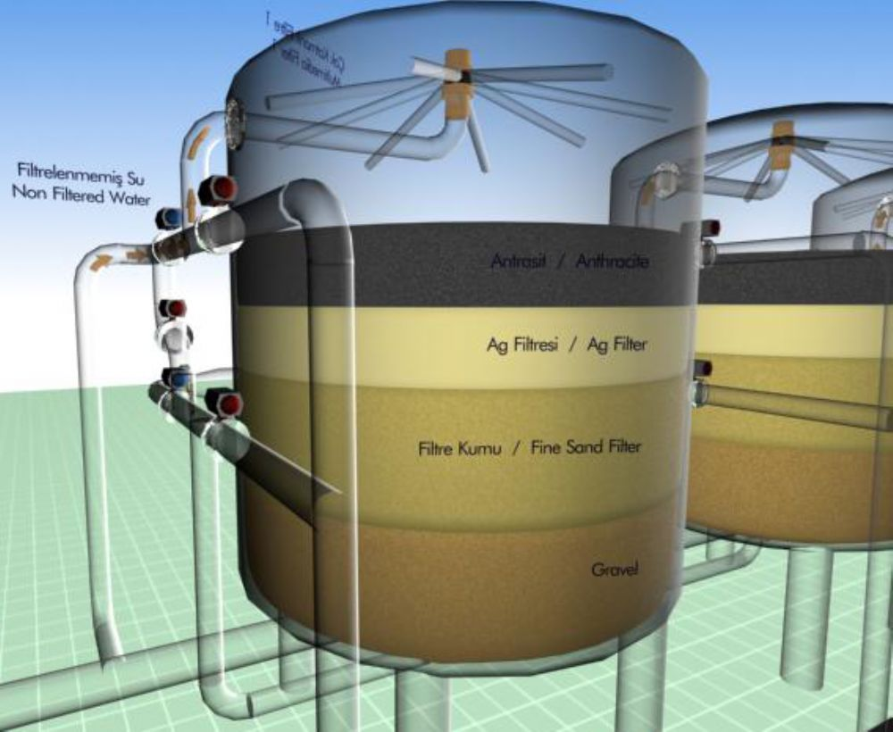

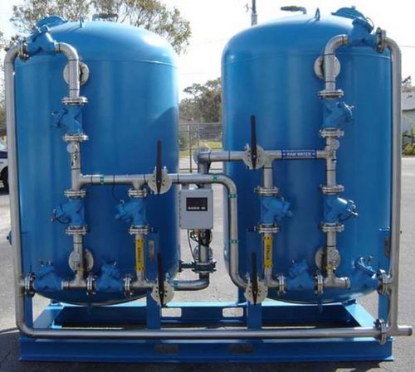

Filtration Capacity (20) M³/hr. Multi Media arranged inside vessel.

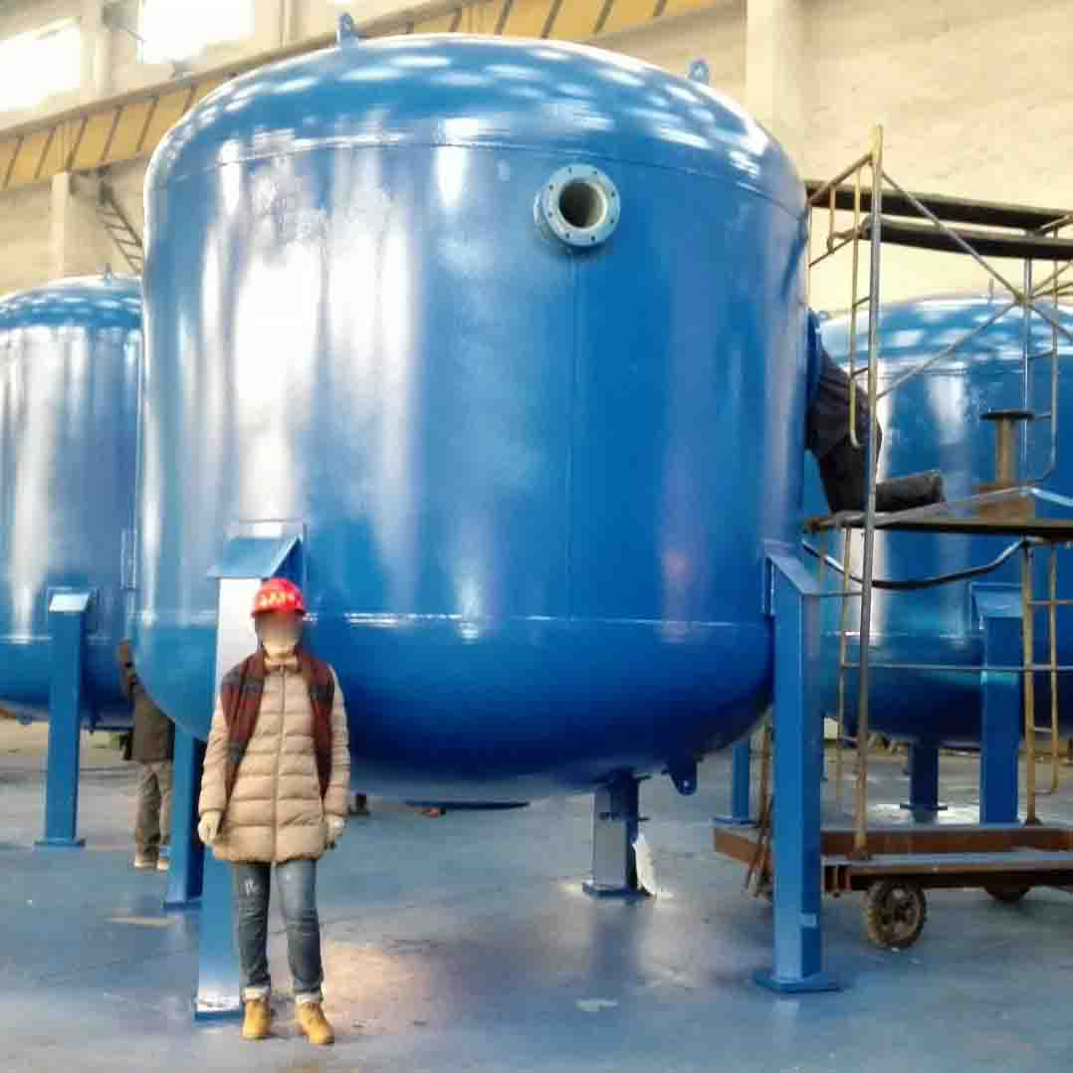

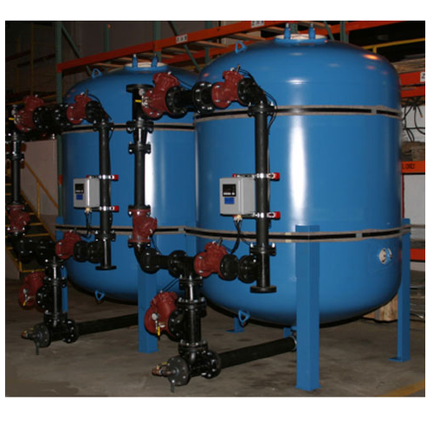

Filtration Capacity (35) M³/hr. Media Filter Capacity (100) M³/hr.