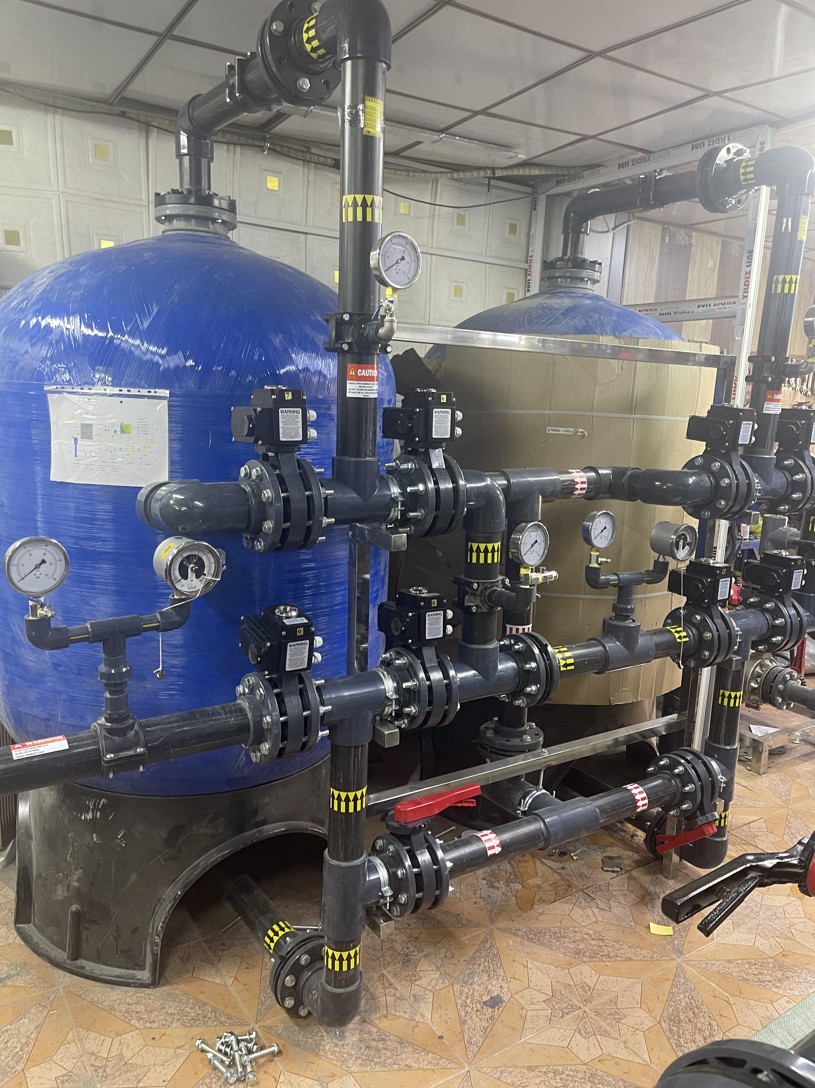
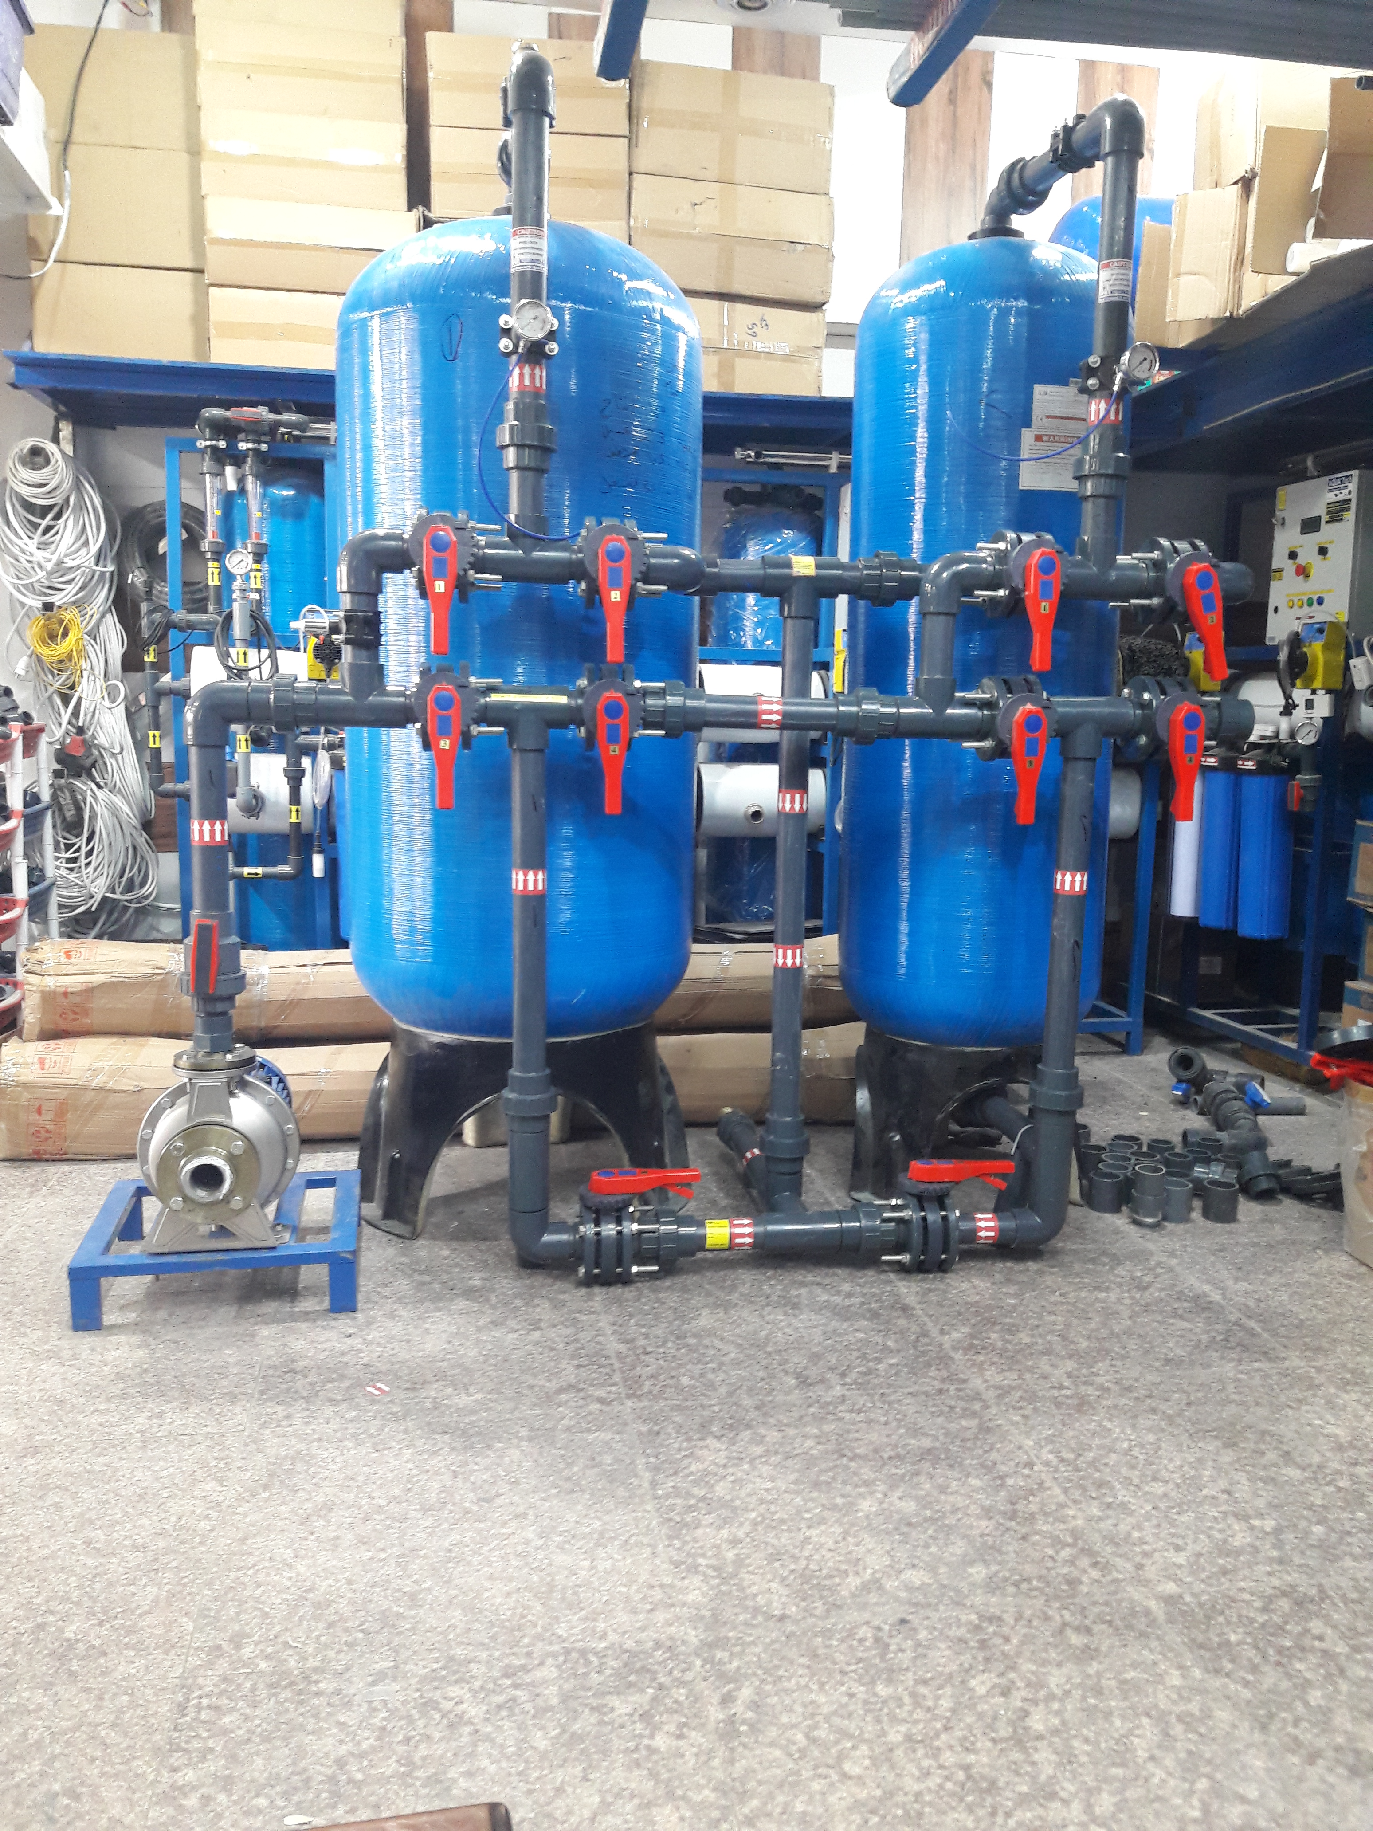

Filtration capacity (15) M³/hr. Filtration capacity (40) M³/hr.

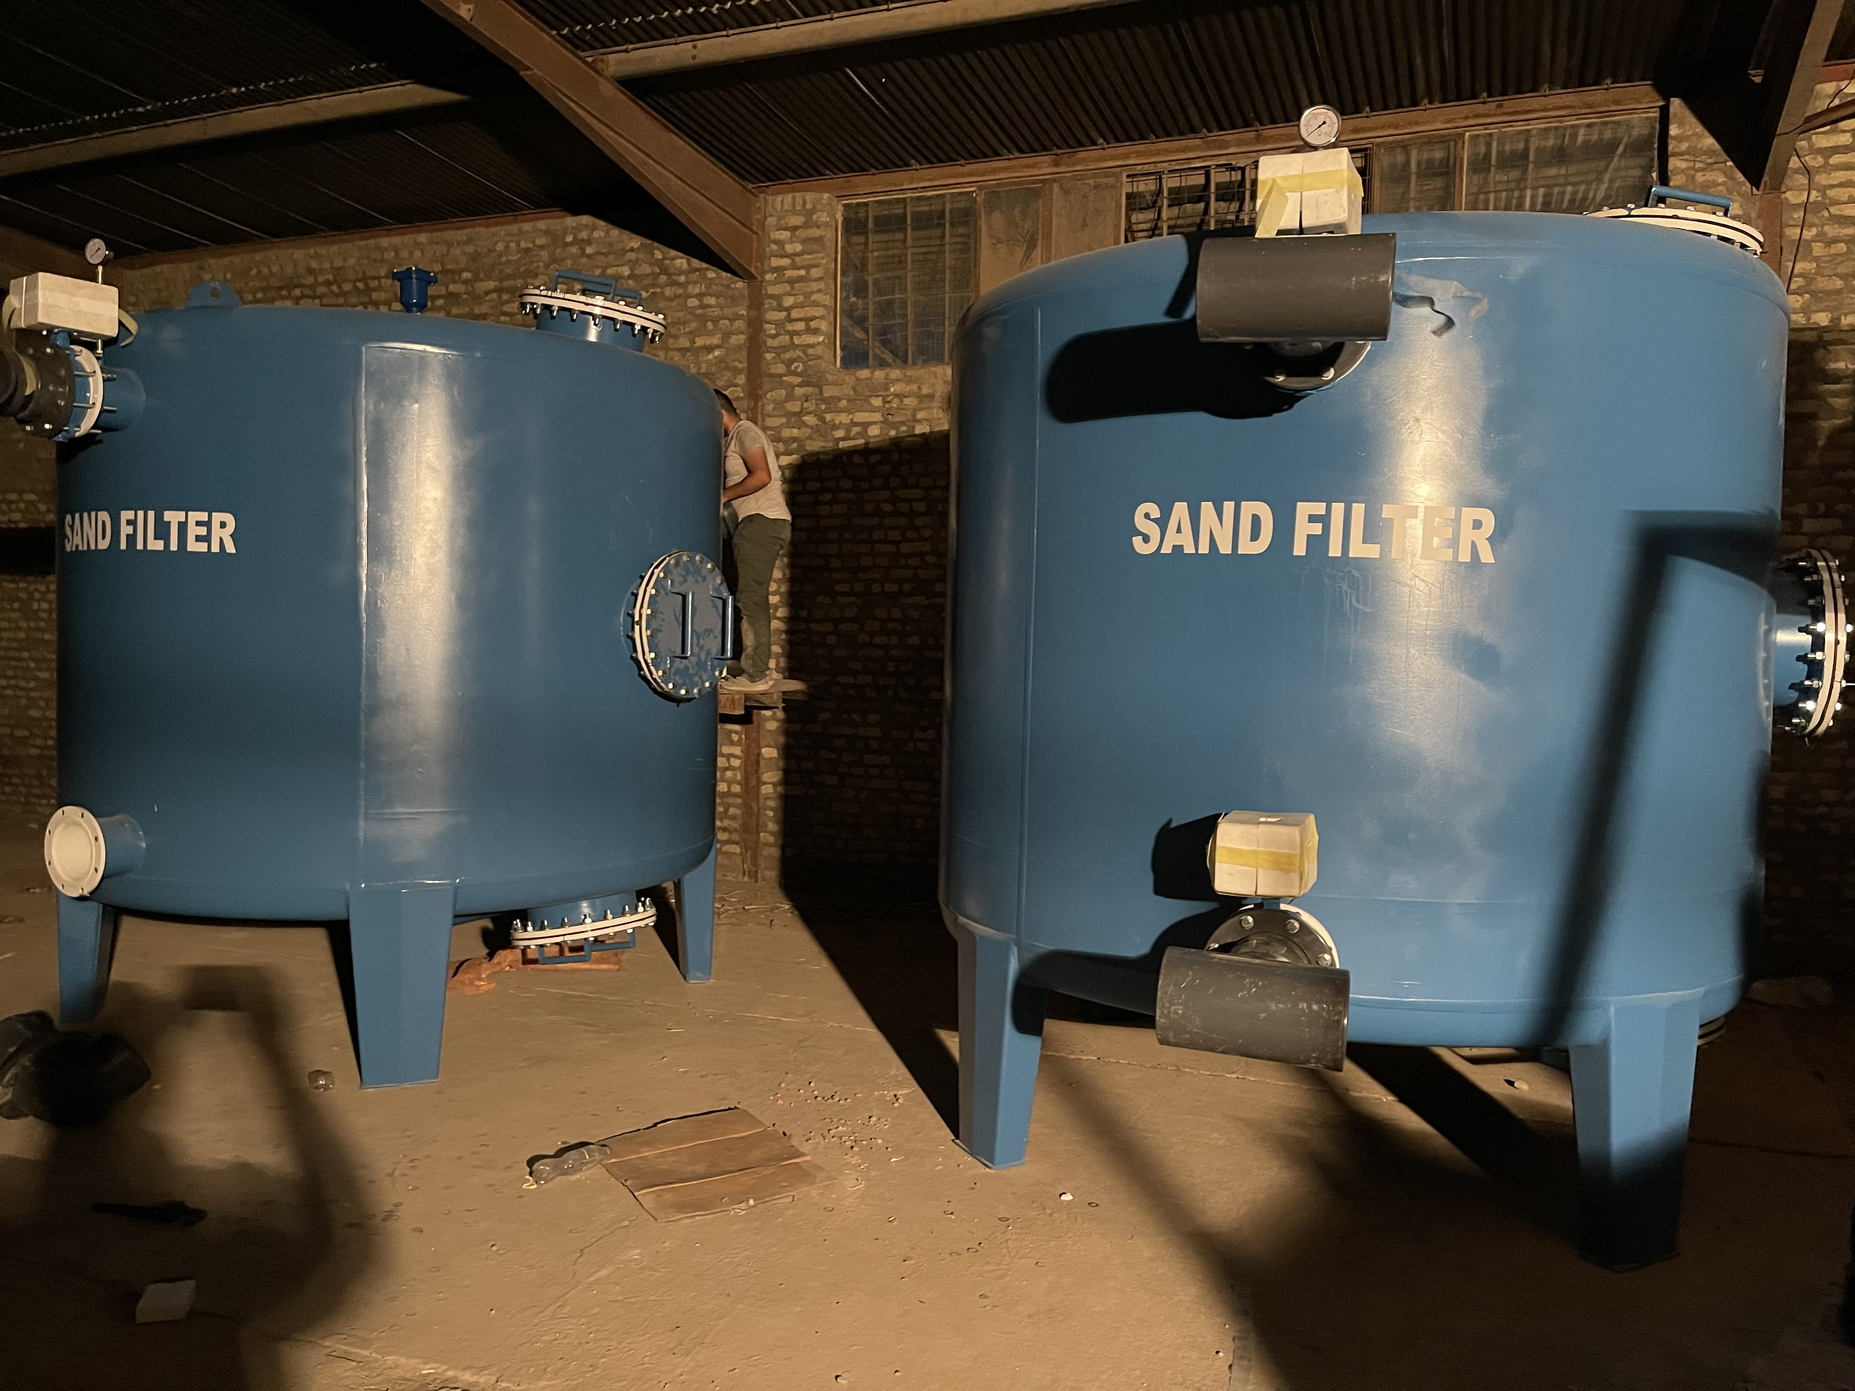
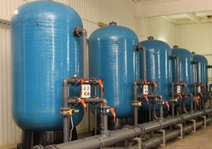

Filtration Capacity (50) M³/hr. Filtration Capacity (200) M³/hr.

